WEEK 11 ASSIGNMENT RDBMS

**1**. **Consider the CUSTOMERS table having the following records**

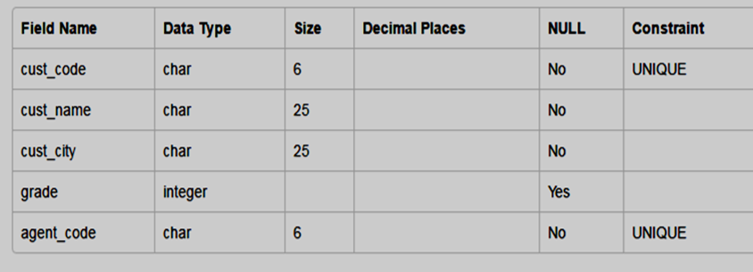

1. To describe the customer table.
2. Fetch all the fields of customer table.
3. Fetch the records of whose city is Madurai.
4. Fetch the records of whose city is Madurai. the details of the customer’s agent code=’a1207’.
5. Write an SQL query to print all customer details from the customer table order by

grade.